TCOE Summer Basketball Camp 2024
Directed by
COACH KEVIN MCDUFFIE
Girls & Boys Ages 5-14

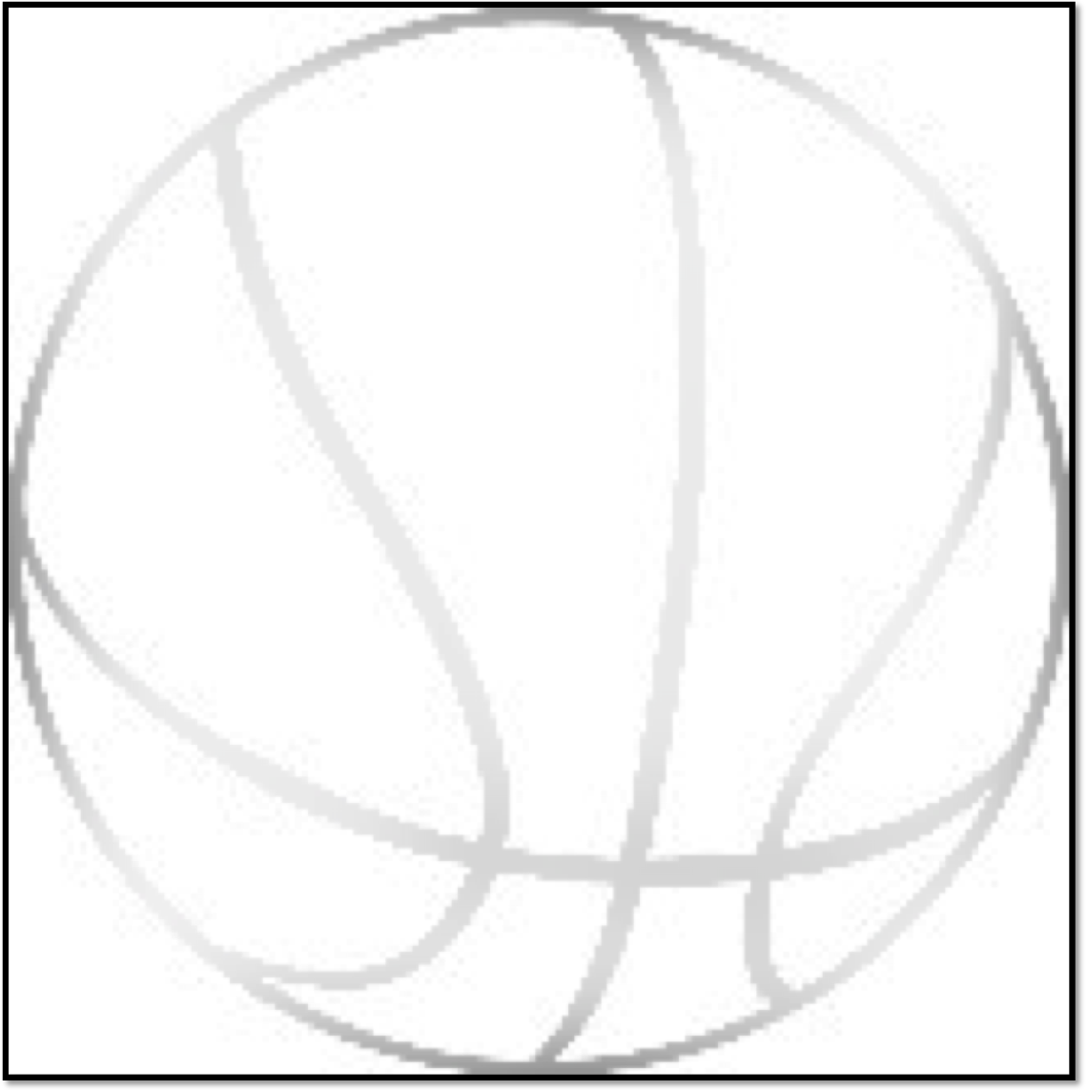

Place: Clarksville Middle School – 6535 S. Trotter Road, Clarksville, MD 21029

Date: June 24 - Aug. 9, 2024

Time: 9:00 – 3:30 (Half Day sessions 9am -12pm or 1pm -3:30pm)

Cost: $250 per week - $150 Half day

Weekly Cost: Camp Highlights 3 plus paid weeks ($200 per week) Experienced Coach’s / Camp T-shirt

Before / After Care Available $50 each (8am -9am / 3:30pm -4:30pm)
Visit Website to enroll online: MCDUFFIECAMPS.com
Email : mcduffiecamps34@aol.com or 443-474-4200

Name: ________________________________________________________________________________________________________________________

Home Address:_______________________________________________________________________________________________________________

Email:________________________________________________________ _________Phone_________________________________________________

School Name:____________________________________________________________ AGE __________________ Shirt Size_____________

June 24 – 28 FD ___ HD___ July 8 -12 FD____ HD___ July 15 - 19 FD __ HD __ July 22-26 FD____ HD____

July 29 –Aug. 2 FD______HD______ Aug 5 -9 FD_____ HD ______

Additional COST $50 each _____ Before Care _____ After Care ____

Parent/ Guardian Name:__________________________________________________________________________________________________________________

Will camper be taking medication during camp? Yes_______ No____ if yes please explain:

I hereby register the above camper/campers as a participant in the basketball program. I certify that I am the parent/ legal guardian of the said camper/campers and hold harmless the TCOE. from any and all liability for any injury, illness or condition that may arise as a result of participation in this program. I also certify that the above camper/campers birth date / age is accurate as indicated.

___________________________________________________________________________________________________ Date:________________________________________
Signature of Parent/Guardian

Mail application/check: Coach McDuffie P.O Box 652 Clarksville, MD 21029
Zelle payments: Mcduffiecamps34@aol.com NO REFUNDS

The information is neither sponsored nor endorsed by HCPSS or the school

